**Snowflake Topics Novice**

**1. Security Fundamentals in Snowflake**

Snowflake provides robust security measures to protect data, covering a wide range of security practices across all layers: encryption, user authentication, access controls, and more. Here's a detailed breakdown:

* **Authentication**: Snowflake supports multiple authentication methods including:
  + **Single Sign-On (SSO)**: Using federated authentication with providers like Okta, Azure AD.
  + **Multi-Factor Authentication (MFA)**: Enhances security by requiring an additional authentication step.
  + **Key Pair Authentication**: Public and private key pairs can be used for secure authentication for scripts and programs.
* **Encryption**:
  + **At-Rest Encryption**: Snowflake encrypts all data at rest using AES-256 encryption. This encryption is applied to all stored data, including backups and metadata.
  + **In-Transit Encryption**: All data transferred between Snowflake and client applications is encrypted using TLS (Transport Layer Security).
* **Access Control**:
  + **Role-Based Access Control (RBAC)**: Snowflake uses RBAC to restrict access to data and functionality based on roles. Administrators can assign roles to users or other roles, granting the necessary permissions.
  + **User Privileges**: Each user has a specific set of permissions to access objects within Snowflake. These can include the ability to run SQL queries, modify tables, and access warehouses.

**Query for creating the user and assigning the role**

CREATE USER user1

PASSWORD = 'Password'

LOGIN_NAME = 'login_user'

DEFAULT_ROLE = 'data_scientist'

MUST_CHANGE_PASSWORD = TRUE

COMMENT = 'User for Data Science team';  
  
**Data Masking**: Snowflake supports dynamic data masking to ensure sensitive data is protected by applying masking policies that transform sensitive data when accessed by unauthorized users.  
 **Query for applying the masking :**  
SELECT

CASE

WHEN CURRENT_ROLE() IN ('hr_manager', 'compliance') THEN C3

ELSE 'XXX-XX-XXXX'

END AS masked_ssn

FROM CUSTOMERS;

* **Network Policies**: Snowflake allows customers to configure network policies to control the IP addresses and networks that are allowed to access their Snowflake account, adding an extra layer of security.
* **Monitoring & Auditing**:
  + **Logging**: Snowflake provides detailed logging and auditing capabilities, recording every action performed in the account, including login attempts, queries, and changes to permissions.
  + **Access History**: Administrators can track query history and access patterns to detect unauthorized access.

**2. Data Staging in Various Clouds & On-Prem**

Snowflake uses staging areas to temporarily store data before it's loaded into tables or extracted from tables for further processing. These stages can exist in the cloud or on-premises, and Snowflake supports a variety of staging options.

* **Types of Staging Areas**:
  + **Internal Staging**: Snowflake provides internal stages, which are storage locations managed entirely by Snowflake. These include table stages and user stages.
    - **User Stages**: Each user has a personal stage area to upload files.
    - **Table Stages**: Each table in Snowflake has an associated staging area where files can be uploaded and then copied into the table.

* + **External Staging**: Customers can use cloud-based external stages to store data before loading into Snowflake. Supported cloud platforms include:

**AWS S3**: Snowflake integrates with Amazon S3 buckets to stage data.  
**Query**:  
CREATE STAGE my_s3_stage

URL = 's3://mybucket/data/'

CREDENTIALS = (AWS_KEY_ID='your_key_id' AWS_SECRET_KEY='your_secret_key');

* + - **Azure Blob Storage**: Snowflake supports Azure Blob storage as a staging area for loading and unloading data.
    - **Google Cloud Storage (GCS)**: Snowflake can use GCS buckets to store and access staged data.
* **On-Prem Staging**:
  + **Hybrid Approaches**: For organizations using on-premise data centers, Snowflake can interact with various file transfer mechanisms (like FTP or SCP) to move data from on-prem environments to cloud storage stages.
  + **On-Prem to Cloud**: The process typically involves transferring data from on-premise storage to an external cloud staging area before loading into Snowflake.
* **Best Practices for Staging**:
  + **Compression**: Compress large data files before uploading them to a stage to save time and storage space.
  + **Partitioning**: Break large files into smaller chunks to improve data loading efficiency.
  + **Error Handling**: Use Snowflake's error logging features to capture issues with loading data from a stage, ensuring smooth operations.

**3. Data Ingestion from Various Clouds**

Data ingestion refers to the process of loading data into Snowflake from different cloud sources. Snowflake provides multiple options for ingesting data from various clouds, ensuring seamless integration with cloud services.

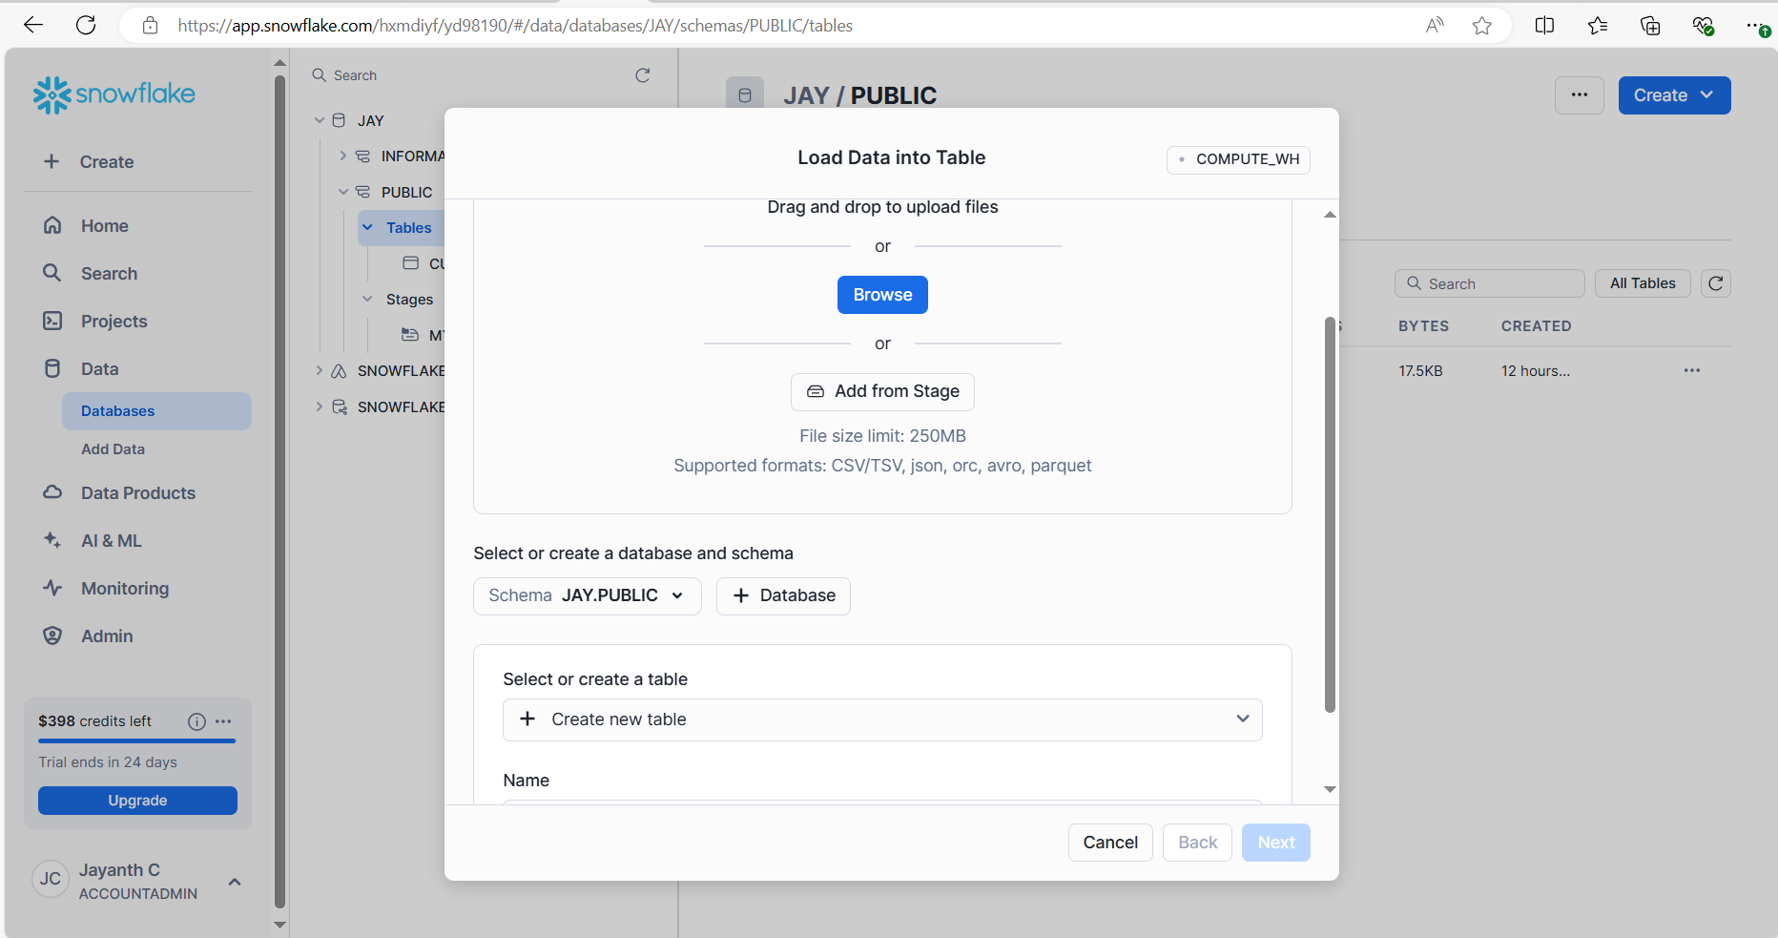

* **Cloud Sources**:
  + **Amazon Web Services (AWS)**: Snowflake natively supports data ingestion from Amazon S3 buckets, allowing direct access to large datasets stored on AWS.
  + **Microsoft Azure**: Snowflake integrates with Azure Blob Storage, enabling easy data ingestion from Azure environments.
  + **Google Cloud**: Snowflake can ingest data directly from Google Cloud Storage (GCS), facilitating easy movement of data from Google Cloud to Snowflake.
* **Methods of Data Ingestion**:
  + **Bulk Loading**: This is used when large volumes of data need to be loaded from cloud storage like S3, Azure Blob, or GCS. The COPY INTO command is used to efficiently load data from these sources.
    - **Pattern Matching**: When loading multiple files, Snowflake allows for pattern matching in file names (e.g., *.csv) to load all files matching the pattern.
    - **Parallel Loading**: Snowflake automatically loads files in parallel to maximize speed.
  + **Snowpipe**: This is Snowflake’s continuous data ingestion service. Snowpipe allows for the automatic loading of data as soon as it arrives in a staging area (e.g., an S3 bucket).
    - **Serverless Model**: Snowpipe doesn’t require dedicated resources like virtual warehouses and runs in the background.

**Event-Driven Ingestion**: With cloud notifications (e.g., AWS SNS), Snowpipe can trigger data ingestion automatically when new files are uploaded to cloud storage.  
**Query**:  
REATE OR REPLACE PIPE my_pipe AS

COPY INTO sales_transactions

FROM @my_stage

FILE_FORMAT = (TYPE = 'CSV' FIELD_OPTIONALLY_ENCLOSED_BY='"')

ON_ERROR = 'CONTINUE';

* **Data Streaming**: Snowflake supports ingestion from streaming sources, such as Kafka, through the **Snowflake Kafka Connector**. This connector ingests streaming data into Snowflake tables in near real-time.
* **ETL Tools**: Snowflake integrates with popular ETL (Extract, Transform, Load) tools like **Informatica**, **Talend**, **Matillion**, and **Fivetran**, which can simplify data ingestion from various cloud sources.
* **APIs**: For more customized ingestion pipelines, Snowflake provides a **REST API** that allows developers to programmatically load data from various cloud environments into Snowflake.

